

Department of Aerospace Engineering
JGI Global Campus, Jakkasandra Post, Kanakapura Taluk,
Ramanagara District, Karnataka, India – 562112

INTERNSHIP REPORT ON

“STUDY ON TOOL DESIGN FEATURES FOR A TYPICAL COMPOSITE PART”

by

SALMAN FARIS E T (22BTRAS038)

at
CSIR- NATIONAL AEROSPACE LABORATORIES
BANGALORE, 560017



From: 10/06/24 To: 10/07/24

BACHELOR OF TECHNOLOGY
in
AEROSPACE ENGINEERING

Signed Internship Certificate from company to be attached as second page

CERTIFICATE

This is to certify that SALMAN FARIS E T, USN No. 22BTRAS038 student of JAIN UNIVERSITY pursuing B Tech Aerospace has successfully completed Internship titled “STUDY ON TOOL DESIGN FEATURES FOR A TYPICAL COMPOSITE PART” during 10-06-2024 to 10-07-2024 under the guidance of Mr. SENTHIL NATHAN K, Principal Scientist, ACD towards the fulfilment of the requirements of their university.
We wish SALMAN FARIS E T the very best in all his future endeavors.

Mr. Senthil Nathan k
Principal Scientist, ACD
Internship Guide
CSIR-NAL

CONTACT DETAILS OF COMPANY
Reporting officer:  Name, Designation | Mr. SENTHIL NATHAN K  PRINCIPAL SCIENTIST, ACD
Address of the company | Council of Scientific and Industrial Research  National Aerospace Laboratories  Bengluru-560017
Telephone No. | +91 9449970777
Mail id of the point of contact

INTERN DETAILS
Name  USN No. | SALMAN FARIS E T  22BTRAS038
Address | ETTILATHODIYIL HOUSE  PATTAMBI, PALAKKAD DISTRICT,  KERALA, 679303
Telephone No. | 9946989668
Mail Id. | 22btras038@jaununiversity.ac.in

Approved the Internship Report:
Mentor  Name: | Class in charge  Name: | Director / Program Coordinator
Department of Aerospace Engineering
Faculty of Engineering and Technology
JAIN Deemed to be University

ACKNOWLEDGEMENTS

I would like to thank Dr. Abhay A Pashilkar, Director, National Aerospace Laboratories, for giving me this opportunity to work at a premier research institute like NAL.

I take this opportunity to thank Mr. Senthil Nathan K, Principal Scientist for his constant guidance, encouragement and help during the internship.

I thank Mr. Giridharan A, Sr. Technical Officer, for his constant support towards my internship.

I thank Mr.Rajesh Kumae S, Technician for guidance and support throughout the internship.

I thank Dr. Antonio Dsavis, HOD for the support and encouragement for doing the internship.

I also thank Dr. Vishnu V, Placement coordinator for the support and making the whole internship process easy for us.

CONTENTS

1. | Weekly overview of internsip | 7
2. | Objective | 11
3. | Introduction | 11
4. | Detail design methodology | 11
4.1 | General management | 12
4.2 | Station Diagram | 12
4.3 | Layout | 12
4.4 | Component Drawing | 13
4.5 | Assembly Drawings | 13
4.6 | Installation Drawing | 13
4.7 | Needs of CAD Modelling | 13
4.8 | 3D modelling and 2D drawing generation of aircraft components | 14
4.8.1 | Bush | 14
4.8.2 | Metal Insert | 15
4.8.3 | Root Fitting Bolt | 16
4.8.4 | Cover Plate | 17
4.8.5 | Sleeve Rear | 18
4.8.6 | Spacer | 19
4.8.7 | Clip @ spar | 20
4.8.8 | Bracket | 21
4.9 | Weight comparison, CAD weight S reference weight | 22
5 | Tool generation | 22
5.1 | Core nose rib | 22
5.2 | Tool for core nose rib | 22
6 | Composite part manufacturing | 24
6.1 | Composites | 24
6.2 | Characteristics of composites | 24
6.3 | Mechanism of composites | 24
6.4 | Material and consumables required for tooling and manufacturing | 25
6.5 | Layup | 25
6.6 | Debulking | 25
6.7 | Bagging | 26
6.8 | Curing | 26
6.9 | Post curing | 26
6.10 | Testing methods | 27
7 | Skills acquired | 29
8 | challenges and solutions | 29
9 | conclusion | 29

1. WEEKLY OVERVIEW OF INTERNSHIP ACTIVITIES

WEAK | Date | Day | Name of The Training / Module Completed/Practical Learning
1. | 10/06/24 | Monday | I was introduced to the basics of the software Draft Sight. How to draw lines, shapes, fillets, and chamfer. How to mention the dimensions and so on.
1. | 11/06/24 | Tuesday | I drew the following in draft sight:  - Bush  - Metal insert  - Cover plate  - Root fitting tool  - Sleeve bar
1. | 12/06/24 | Wednesday | I was introduced to the software CATIA V5-6R2020. It is a 3d modeling platform. I got to know about different workbenches.
1. | 13/06/24 | Thursday | Drew the 3d model of the following in Catia:  - Bush  - Metal insert  - Cover plate  - Root fitting tool  - Sleeve bar
1. | 14/06/24 | Friday | I was instructed to draw a tool named nose rib  Since I am new to the software it took some time to study the given tool  I was also introduced to NMG (numerical master geometry) and the method of drawing by creating new planes (by hiding the xy plane, yz plane, and zx plane).  I just started drawing and saved it.

WEAK | Date | Day | Name of The Training / Module Completed/Practical Learning
2. | 18/06/24 | Tuesday | I had finished drawing the given tool with the guidance of the staff at NAL, ACD CAD division.  I was guided to prepare the report on steps I followed for drawing  So, I prepared a report in MS Word.
2. | 19/06/24 | Wednesday | I worked on the report in the morning section  Then I was guided for drafting the drawn models in CATIA:  - Bush  - Metal insert  Also corrected the suggested correction of drawn models in auto draft
2. | 20/06/24 | Thursday | Today I worked on the report  Also, I had drafted the following in CATIA V5-6R2020:  - Cover plate  - Root fitting tool  - Sleeve bar
2. | 21/06/24 | Friday | The guide spotted some mistakes in my drawings and instructed me to correct them.  So, I was working on that.

WEAK | Date | Day | Name of The Training / Module Completed/Practical Learning
3. | 24/06/24 | Monday | The day started with a small lecture on tolerance, GD&T, concentricity, transition fit, clearance fit, interference fit, and circularity.  I was provided with two composite drawings using planes and NMG as reference.  - Clip @ spar  - spacer  I modeled it in CATIA V5-6R2020
3. | 25/06/24 | Tuesday | I drafted the drawings that I did in the previous day  Also worked on the report
3. | 26/06/24 | Wednesday | The day waas started with a lecture on tools, material selection for making required tools, specifications, comparison of composites with other materials, and so on.  There were some corrections pointed out by the guide on the drafting I did the previous day, so I worked on that
3. | 27/06/24 | Thursday | I had drafted the tool core nose rib  There was a lecture on the selection of materials, coefficient of thermal expansion, failure theory, and so on
3. | 28/06/24 | Friday | The whole day I was working on the report. I had submitted my report to guide for corrections.

WEAK | Date | Day | Name of The Training / Module Completed/Practical Learning
4. | 01/07/24 | Monday | I had got to model a new composite part named spacer. Also worked on report
4. | 02/07/24 | Tuesday | I had drafted the breaker. Later worked on the report.  There was a lecture in the evening.
4. | 03/07/24 | Wednesday | Today I worked on bolted lap joint. I given dimensions and modeled it. Also corrected drawings of clip @ spar, which was instructed by the guide.
4. | 04/07/24 | Thursday | There were some corrections on the bolted lap joint model, so I corrected them. Then after I had worked on report.
4. | 05/07/24 | Friday | I got an opportunity to visit the manufacturing sector. I had seen water jet cutting and then worked on report

2. OBJECTIVE
The objective is to understand the process of detail design and engineering of aircraft structure, which includes,
- Detail design process, CAD modeling, and drawing preparation for aircraft components
- Exposure to tooling and manufacturing of composite components.

3. INTRODUCTION
Advanced composites have become increasingly popular in the aerospace industry due to their exceptional combination of lightweight and high strength properties. Computer-Aided Design (CAD) plays a crucial role in the design process, allowing engineers to create detailed 3D models of structural components. These 3D models enable visualization of part characteristics, evaluation of assembly fits, and precise determination of mass properties. The CAD models also serve as the foundation for detailed technical drawings and manufacturing guidelines. Comprehensive understanding of the fabrication techniques for composite specimens is essential for the successful development and implementation of these advanced materials in aerospace applications.

4. DETAIL DESIGN METHODOLOGY
Detailed design is an important step in the product development process, where the conceptual design is converted into component-level drawings and specifications. This involves collecting input data like locations and configurations of various components within the system. The detailed design of structural parts is carried out by maintaining the functional requirements, ensuring interchangeability (ICY) points, defining the outer contour (NMG), and adhering to the overall system requirements. The various levels of detail design and drawing (Figure 1) by incorporating all the requirements are explained as in the following:
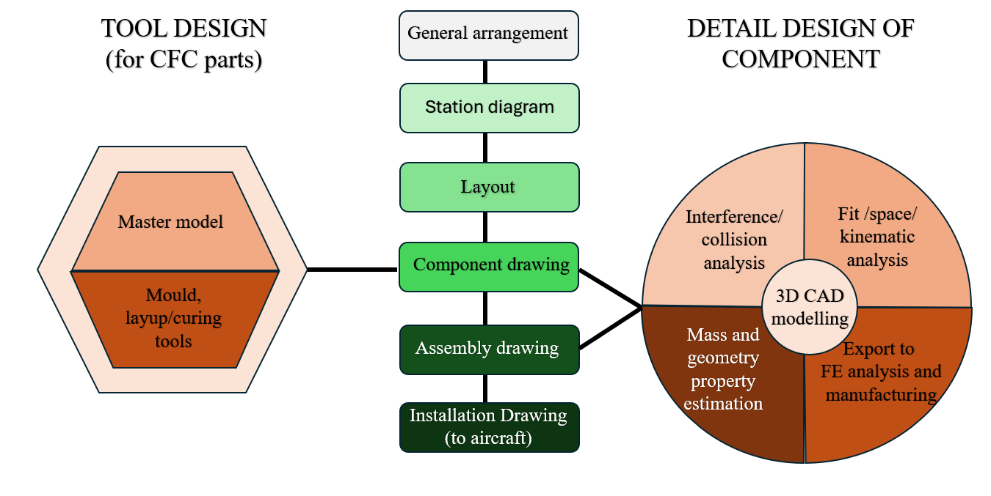
Figure 1 Flow chart of Detail Design process for aircraft Component

4.1 General management
General management is the basic three view drawing of an aircraft that represents the important components, installation details, and corresponding locations.

4.2 Station diagram
The drawing which provides information about the structural components such as spar, rib, stringer, and frames of an aircraft component. The station diagram provides contour details such as:
- Numerical Master Geometry (NMG).
- Attachment details such as wing-fuselage, wing-flap & aileron.
- Kinematic positions of control surfaces.
- Definition of interchangeability (ICY) points.

4.3 Layout
The layout of a component is a crucial feature of the design and manufacturing process. It contains the complete configuration, including the size, shape (such as C, I, or J-section), fastening mechanisms, attachments, ply details (if made of composite material), and tolerances. This layout provides essential information about the relationship between the adjacent components, ensuring the overall fit and functionality of the assembly.

4.4 Component drawing
The data extracted from the layout is an important step in the manufacturing process. This information is used to generate the 3D CAD models and 2D drawings of each component, which describe the size, shape, and features of the product. The standard drawing provides detailed information about the material, manufacturing process, tooling, assembly, and inspection requirements for the component. This detailed documentation ensures that the final product meets the necessary specifications and quality standards, enabling efficient and reliable production

4.5 Assembly drawings
An assembly drawing explains essential information regarding the relationship between mating parts, their connections, and their relative motions. They also provide a detailed visual representation of how the various components of a system or product fit together and interact with each other.

4.6 Installation drawings
Installation drawing is made using a group of assembly drawings to form a major assembly of an aircraft which are installed directly to the aircraft.

4.7 Needs of CAD Modelling
- Helps in visualization of a 3D fashion which is easily understandable and perceivable by humans.
- For generating 2D drawing views.
- Helps in calculating the estimated weight, properties and dimensions in the virtual environment.
- CAD models can easily be imported into any FEA environment in the form of a ‘.stl ’ file format. This helps in validating the design by analyzing the loads.
- CAD models can also be easily fed to the CNC machines in the form of ‘.stp’ file format. This saves a lot of time in coding the dimensions of the specimen in the CNC machines
- CAD models can also be used in verifying the assembly process by creating an assembly virtually and checking if there’s any error present. This eliminates almost all errors during the actual assembly.

4.8 3D modelling and 2D drawing generation of aircraft components
This report presents a detailed analysis of the CAD modeling and drawing of aircraft components utilizing the CATIA software.

4.8.1 Bush
Bush helps to reduce wear and tear between all the moving parts, acting like a smooth bearing surface. Keeps the plane running smoothly and cuts down on maintenance costs
Material used: Stainless-Steel rod, Density is 7.8g/cc.
1. | 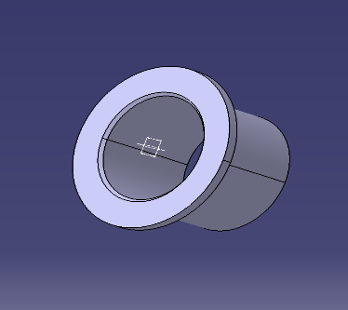
a. | 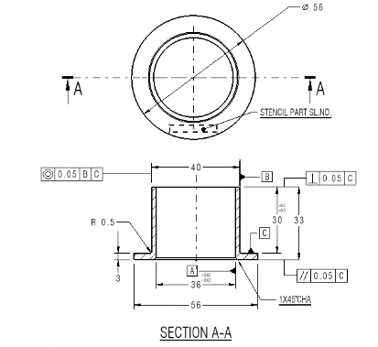
Figure 2: | - CAD model of Bush, a) drawing of bush

4.8.2 Metal Insert
metal inserts are components that are embedded into composite brackets. It has knurling on outside surface to prevent any rotation during its operation. The metal insert serves to support and enable the rotation of a bolt, with a clearance fit provided on the inner diameter. This design allows for smooth and reliable operation, ensuring the integrity of the overall assembly
Material used: Ti-6Al-4V.; Density: 4.43 g/cc
1. | 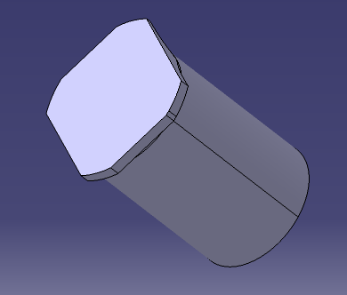
a. | 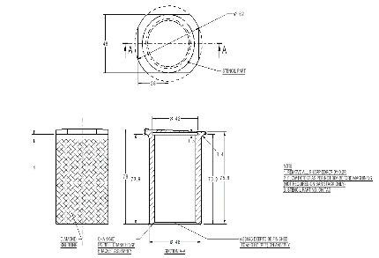
Figure 3: | - CAD model of metal insert, a) drawing

4.8.3 Root Fitting Bolt
A root-fitting bolt is a crucial component used in manufacturing to attach various elements to a primary framework. These bolts are designed to ensure stability and precise alignment. The primary function of a root fitting bolt is to evenly distribute loads, minimize vibration, and maintain the integrity of the connection under diverse operating conditions.
Material used: C M Steel Rod, Density: 7.8 g/cc
1. | 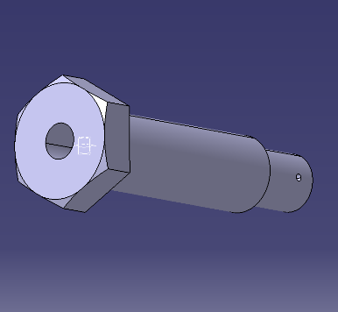
a. | 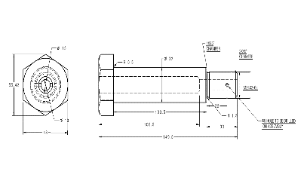
Figure 4: | - CAD model of root fitting bolt, a) drawing

4.8.4 Cover Plate
A cover plate is used to attach the rear fitting assembly using a bolt and nut. It helps to secure the bearings in its position.
Material used: A1 alloy plate, Density: 2.8 g/cc
1. | 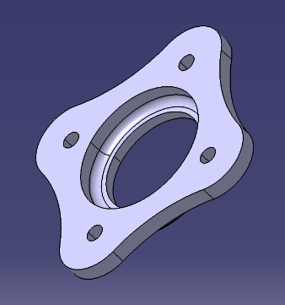
a. | 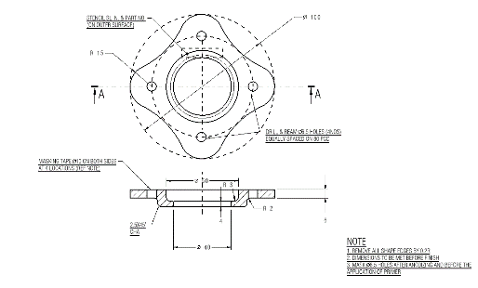
Figure 5: | - CAD moadel of cover plate, a) drawing

4.8.5 Sleeve Rear
Ensure precise alignment and reduce friction between moving parts.
Material used: Aluminum alloy rod, Density: 2.8 g/cc.
1. | 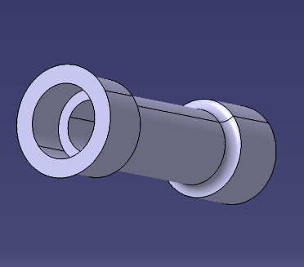
a. | 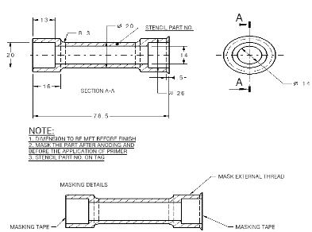
Figure 6: | - CAD model of sleeve rear, a) drawing

4.8.6 Spacer
Spacer is used to maintain the spacing and support the antenna. One surface is connected to the contoured part and another surface is connected to the antenna.
Material used: Al Alloy Plate; Density: 2.8 g/cc
1. | 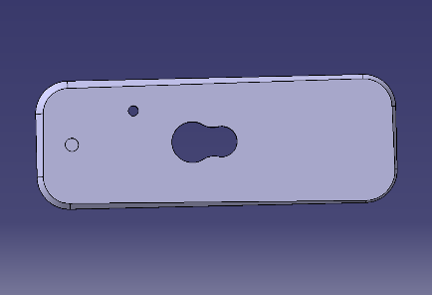
a.
Figure 7: | - CAD model of spacer, a) drawing

4.8.7 Clip @ spar
Clip at Spar is a composite part that is manufactured using Carbon Unidirectional Prepreg. The manufacturing process involves a layup sequence, which is carefully designed to determine the orientation, direction, and number of fiber layers. This approach ensures that the final product exhibits the desired mechanical properties and structural integrity. Density is 1.58 g/cc.
1. | 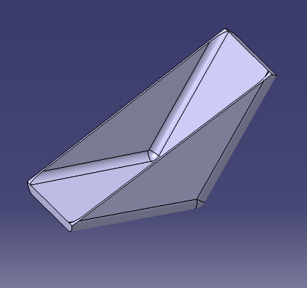
a.
Figure 8: | - CAD model of clip@spar, a) drawing

4.8.8 Bracket
bracket meets the stringent requirements of the aerospace industry. The bracket is a critical metal component, needs to be modelled within the parameters set by the NMG to ensure proper integration and functionality.
1. | 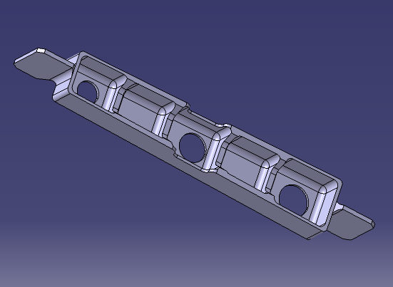
a. | 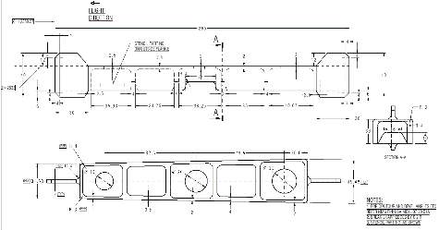
Figure 9: | CAD model of bracket, a) drawing

4.9 Weight comparison, CAD weight VS reference weight
NAME | MATERIAL | REFERENCE  WEIGHT  (KG) | CAD WEIGHT | % ERROR
Bush
Metal insert | Ti-6A1-4V | 0.209 | 0.209 | 0
Root fitting bolt | CM Steel rod | 0.814 | 0.815 | 0.09
Cover plate | A1 Alloy plate | 0.0854 | 0.0854 | 0.01
Sleeve rear
Spacer | A1 Alloy plate | 0.145 | 0.146 | 0.7
Clip @ spar
Bracket
Table 1: weight comparison reference weight vs CAD weight

5. TOOL GENERATION
Tool generation is very important for obtaining well finished and quality composite parts. A tool defines the dimensions of a part that is being constructed. A tool must be capable of withstanding all the temperature and pressure changes during manufacturing.

5.1 Core nose rib
Core nose rib is an aircraft composite part that is found between the spar and nose skin of the leading edge of a wing. It helps to enhance the structure by reducing strength.

1. | 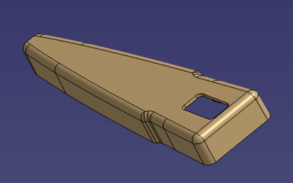
Figure 10: | Core nose rib

5.2 Tool for core nose rib
This tool is designed for the manufacturing of a part named core nose rib. One of the major phenomena that is being considered during the modelling of this tool is spring-in phenomena. This is a male tool consisting of tooling holes at the ends, hexagonal head bolt and part removal plate
1. | 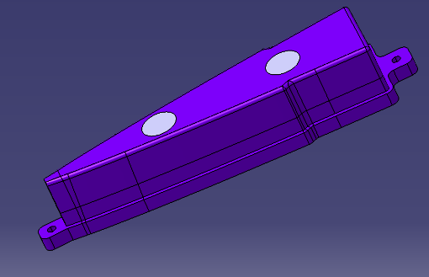
a. | 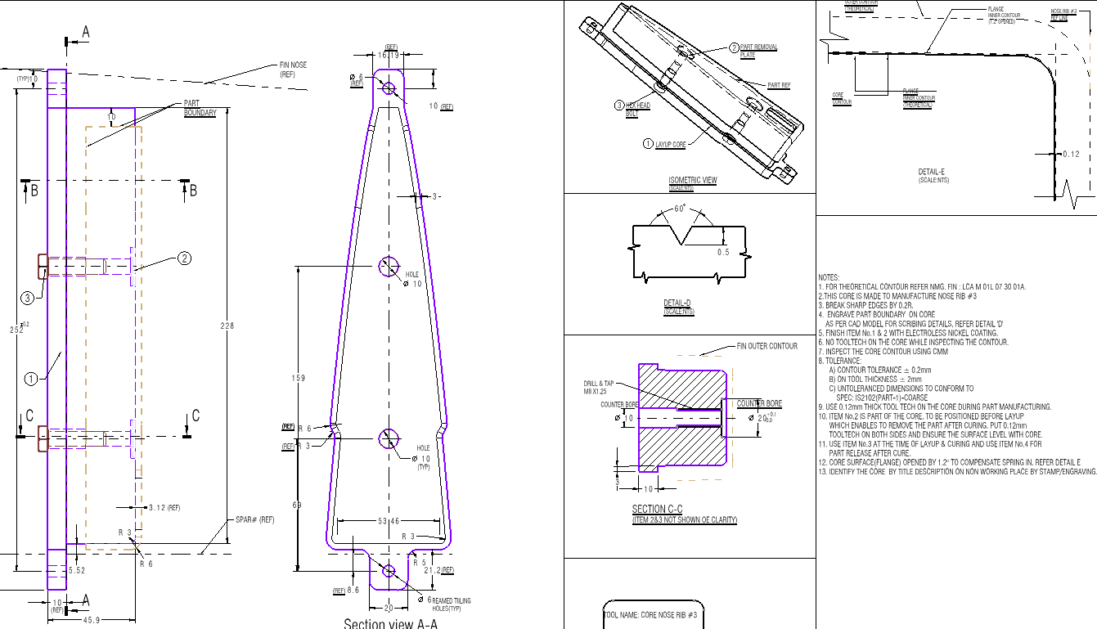
Figure 11: | - CAD model of core nose rib, a) drawing

6. COMPOSITE PART MANUFACTURING

6.1 composites
Composite material is the material which is made up of two or more constituent materials to obtain the desired properties. Composite is also an isotropic, heterogeneous medium composed of two or more materials having distinct physical and mechanical properties. Composites are mixed in a large scale to get the new material with properties distinct from the constituent materials. The combination of these materials in microscopic scale forms alloys.

6.2 Characteristics of composite material
Advanced composites are particularly preferred in Aerospace Industries due to their low density, high specific strength and stiffness, corrosion resistance, vibration damping properties and low thermal expansion coefficient. The material can be tailor-made to meet the required property in a given direction by providing proper orientation and stacking sequence.

6.3 Mechanics of composites
The mechanics of composites refers to the study of how composite materials behave under mechanical loads. It involves analyzing the mechanical properties, behavior, and performance of composites. It can be examined from two perspectives: micro mechanics and macro mechanics
- Micromechanics: focuses on the behaviour of the individual constituents (matrix and reinforcement) and their interactions. Key aspects include:
- Rule of Mixtures: Estimates the overall properties of a composite based on the properties and volume fractions of the constituents.
- Stress and Strain Distribution: Analyses how stresses and strains are distributed within the composite material
- Macro mechanics looks at the composite as a homogeneous material, ignoring the details of the microstructure. Key aspects include:
- Classical Lamination Theory: Used to analyse the behaviour of laminated composites.
- Stiffness and Compliance Matrices: Describe the overall behaviour of the composite material

6.4 Materials and consumables required for tooling and manufacturing
Caul plate: It is a rigid component that is used in layup sequence to obtain certain shape and geometry.
Release Film: It is a type of material that comes in the form of sheet that helps in releasing the component after curing process. It is of two types, viz.; porous and non-porous.
Peel Ply: It is a cloth material used on the layup during curing to obtain a rough, uniform surface finish.
Tool Tech: It is high tensile strength tape material that is usually applied in metal surfaces that act as mold to avoid sticking with the layup.
Breather: It is a fabric material that helps in smooth suction of air from bagging, debulking and curing processes. This also plays a major role of protecting the release film from being sucked out from the layup.
Bagging Film: It is a nylon material that is used in the bagging process to cover up the layup sequence.
General Sealant: It is a rubbery material used with the bagging material to completely seal off the layup region to obtain vacuum in it.
Vacuum valve: It is a device that is used to suck out all the air within the bagging region and reach vacuum pressure. This aid in the strong bonding of the layup.

6.5 Layup
The process of ply by ply laying of a multidirectional or unidirectional laminate on the tool is called layup.

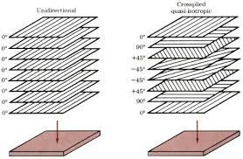
Figure 12: unidirectional and multidirectional layup
(source : https://imechanica.org/files/handout8.pdf)

6.6 Debulking
The next step in preparation of bagging for curing. The laminate was covered with peel ply. Then the release film was placed to prevent the laminate from adhering to plate surface and caul plate. Caul plate was positioned over the laminate, to provide smooth bag-side surface and to help in distributing the pressure evenly over the part. Again, the release film was located before positioning the breather. The breather is a synthetic fabric to allow dispersion of vacuum pressure over the laid laminate and removal of entrapped air or volatile during the curing.

6.7 Bagging
The bag material was used to close the entire system and sealed on the plate around the edges as shown in Figure 8. The design and implementation of the vacuum bag is important, since it provides the means of removing vapors and encouraging the required resin flow.

6.8 Curing
The curing process involves chemically altering the resin properties, either through condensation or addition, to transform laminate layers into their final thermoset form. This is done in an autoclave under full vacuum and 7 bar pressure. The process begins with heating at 2°C/min up to 130°C, followed by a 30-minute dwell. Then, it continues heating at the same rate up to 176°C, with a final dwell of two hours
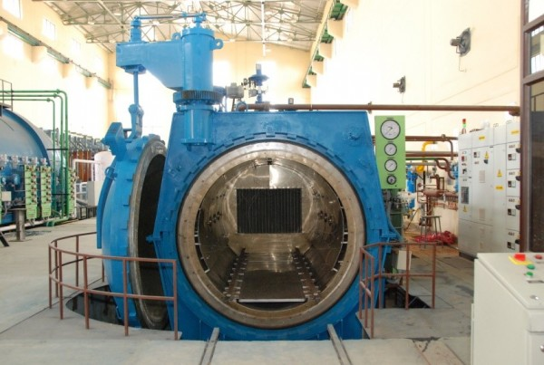
Figure 13: autovlave
(Source : https://www.nal.res.in/en/facilities/autoclaves)

6.9 Post curing
Specimen were post cured at the free condition in the autoclave at 190°C for 4 hours without vacuum and pressure to improve the properties and to complete the cure cycle.
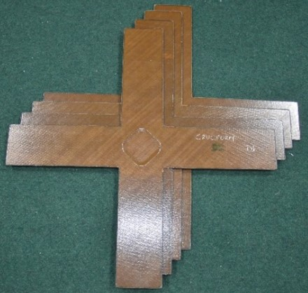
Figure 14: Specimen after cure and post cure

6.10 Testing methods
After completion of curing these laminates need to be tested There are different testing done on composite parts can be classified into two: -
- Non – Destructive testing methods.
- Destructive testing methods.
- Non – Destructive testing methods.
Non – Destructive testing is the technique for assessing the soundness and acceptability of an actual component without affecting the functional properties of the component.
The various non – destructive testing tests conducted are: -
- Air coupled ultrasonic system
- Rapid Scan Linear Array System
- Ultrasound A scan
- Digital Radio Graph X Ray Machine
- Thermography
- Acoustic Emission.
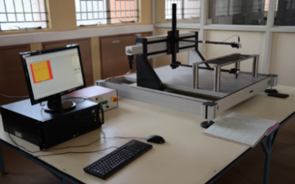 | 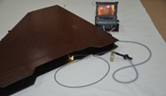 | 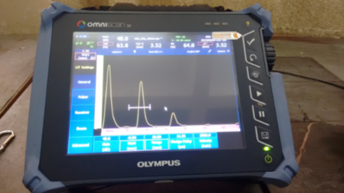
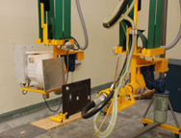 | 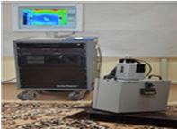 | 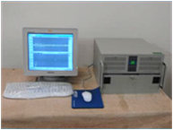

Figure 15 : Non destructive testing Methods

- Destructive testing methods.
This test is carried out to quantify the component properties through mechanical tests. The most frequently encountered mechanical tests for composites are as follows: -
- Tensile test.
- Compression test.
- Impact test.
- Shear test.
- Flexural strength test.
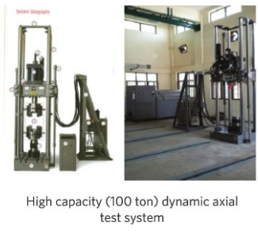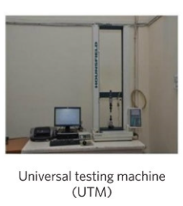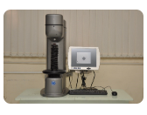
Figure 16: Destructive testing Methods

7. SKILLS ACQUIRED
- Software: During the internship, advanced surface modeling using CATIA was learned to generate doubly curved aircraft parts. DraftSight was utilized for 2D drawing creation.
- Aerospace drawing standard: An aerospace drawing standard is a set of guidelines and specifications regarding the format and conventions for creating technical drawings in the aerospace industry. These standards ensure design intent, manufacturing specifications, and assembly instructions for aircraft components and systems.

8. CHALLENGES AND SOLUTIONS
- Generating a 2D drawing for composite parts is more complex procedure compared to metal parts. This is because composite components often require additional details and considerations to accurately represent their unique material construction and process details.

9. CONCLUSION
Throughout the internship I had an opportunity to work in CAD modelling and drafting. I got to know various tools used for modelling. Also, I learned how to work with NMG. Overall, I got some basics of CAD modelling. With this limited knowledge I had tried to model a tool named core nose rib. Also, I learned to do drafting in Catia: how to take view, give dimensions, apply tolerance.
I understood what is composites, how aircraft components are designed, Importance of tooling in the manufacture of composite parts, spring in phenomena. Also, I got to learn the terms like GD&T, tolerance, transition fit, clearance fit, interference fit and so on.
I was allowed to visit various facilities towards design and development. In total I have learned the basic requirements of an composites Industry.

